A Working OCR Prototype to read and Digitize Doctor’s hand -written Prescriptions

Kshitija Jagushte1 Dr. Neha Ansari2 Dr. Apurva Yadav3

Department of Data Science , Kirti M. Doongursee College of Arts, Science and Commerce, Mumbai University

Email ID : kshitijajagushte24@gmail.com

**Abstract** : In these times, Doctors typically write in incomprehensible handwriting, because they are busy they make it difficult for both the general public and some pharmacists to understand the medications they have prescribed. It is not ideal for them to write the prescription quietly and methodically because they will be dealing with dozens of patients every day and will be drenched with work. As a result, their handwriting is crabbed. This may result in reports or prescriptions consisting of short forms and cursive writing that an individual or pharmacist won't be able to read properly, which will cause prescribed medications to be **misspelled**. Handwritten prescriptions are integral reports in the healthcare domain, serving as directives for patients' medication needs. However, the interpretation and digitization pose significant dares due to the volatility in handwriting styles and the critical nature of accurate transcription. This paper proposes a CNN for feature extraction with recurrent neural networks (RNN) and Optical Character Recognition (OCR) system tailored specifically for handwritten prescriptions that represents an idle solution for **pharmacists**. Leveraging state-of-the-art machine learning algorithms and data pre-processing techniques, for sequence learning, using advanced augmentation techniques to improve generalization. This system demonstrates promising results in accurately recognizing and delivering digitizing handwritten prescriptions. The system pin downs the medicine’s name and the doses from the collected data set with some preprocessing techniques like image processing tasks (i. e noise slimming, image resizing). Hereafter, the pre-processed images will undergo some processing as it will be classified and feature extracted through Convolutional Neural Network and finally Tesseract Optical Character Endorsement technique applied on the medicines with low accuracy in the post-processing phase is employed for text recognition. This system aims to reduce instances of medication name distortion, thereby alleviating pharmacists' uncertainties and enhancing medication management efficiency.Top of Form

**Keywords:** Optical Character Recognition (OCR), Convolutional Recurrent Neural Network (CRNN), Convolutional Neural Networks (CNNs), Recurrent Neural Networks (RNNs), Data Augmentation,

1. Introduction:

Handwritten prescriptions play a crucial role in patient care, serving as instructions for pharmacists to dispense appropriate medications. Regardless of how, physical summary of handwritten prescriptions is protracted and liable to inaccuracy, potentially leading to medication mistakes and adverse patient outcomes. Handwritten character recognition is a field of research in AI, computer vision, and pattern recognition. Humans can easily understand different handwritings using one’s intellect. Similarly, we can persuade same ability into Machine Learning and AI. Optical character recognition (OCR) is a critical task in various applications, including document digitization, automatic license plate recognition, and text extraction from natural scenes. Accurate OCR of medicine names is particularly important for healthcare applications to ensure the correct identification of medication names. In this work, we propose a CRNN-based model for OCR of medicine labels, focusing on robustness and accuracy.

1. **Review:**

In previous research for instance (1), in Image Processing Based Optical Character Recognition has primarily focused on printed script recognition, with minimal attention given to handwritten documents, singularly handwritten prescriptions. Existing literature highlights the detrimental impact of illegible handwriting on medication safety and patient care. Handwritten prescriptions often contain abbreviated terms and cursive writing, complicating interpretation for pharmacists. While OCR Mechanism has been applied in various domains, limited research focuses on handwritten prescription identification. This paper builds upon previous studies by proposing a specialized OCR structure designed to accurately transcribe medication names and doses from handwritten prescriptions.

1. Data Collection

Data is a crucial component of this system for training and testing the deep learning model. The data will be a Real time Data. This will be accomplished by physically acquiring the data by scanning physical materials. By doing so, we can retain maximum veracity in the recognition model, increasing its reliability. However, there is another method by which we may generate a complete prescription data set from scratch by translating the English prescription using Google API and then producing handwritten text in other language.

1. Design

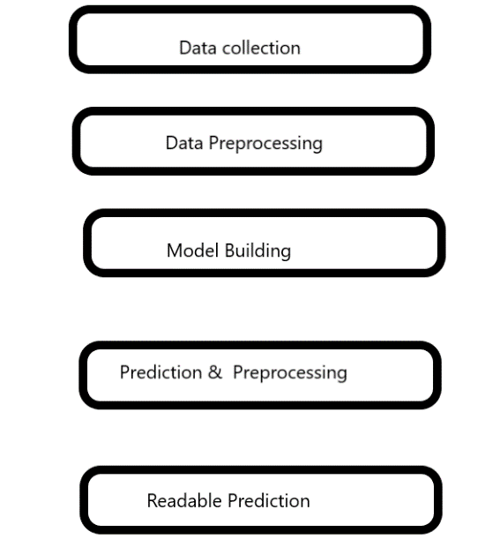

Fig 1. The above figure indicates the methods used to process a doctor’s handwritten note.

1. Data Preparation

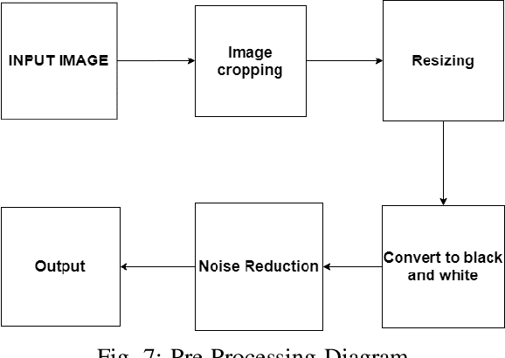

Fig 2 : The above figure show the preprocessing of the images dataset.

#### Label Encoding and Decoding: A class to map characters to indices and vice versa.

* Dataset Class : A custom dataset is used to load images and their corresponding labels .
* Data Augmentation: Vignetting and Lens distortion

1. **Research Domain:**

The research zone encompasses the development and execution of an OCR structure designed to recognize and transcribe doctors' handwritten notes. Key components include image classification, data extraction, continuous model retraining, and database enrichment. The project aims to leverage machine learning, image processing, and natural language processing techniques to enhance the accuracy and productivity of handwritten text validation.

1. **Technology Used:**

The OCR arrangement utilizes handwriting recognition algorithms trained on machine learning and deep learning techniques. Image processing tasks, such as noise pruning and segmentation, are performed using data augmentation techniques including grayscale conversion, resizing, normalization, vignetting, and lens distortion. These augmentations simulate real-world variations in the dataset.

The OCR engine is employed for text recollection, in this duration Python serves as the primary programming language for software implementation. CNNs are used for feature extraction from the input images consisting of seven convolutional layers with max-pooling and batch normalization to extract robust features. RNNs, specifically bidirectional LSTM layers, are used to capture temporal dependencies.

TensorFlow or PyTorch frameworks are utilized for machine learning tasks.

1. **Implementation**:

The implementation phase involves collecting a dataset of handwritten prescription with training and test set comprising images and corresponding text labels and preprocessing them using image processing tasks. The model architecture includes 7 convolutional layers for feature extraction. 2 bidirectional LSTM layers for sequence learning and a fully connected layer for final prediction. We use the Connectionist Temporal Classification (CTC) loss to handle sequence-to-sequence learning, enabling the model to predict sequences of varying lengths. The model is trained using the Adam optimizer with a learning rate of 0.00001. Gradient clipping is applied to stabilize training. The training loop includes: 1) Forward pass. 2) CTC loss Computation. 3) Backward pass. 4) Gradient update. The pre-processed images are then fed into a CNN model for feature extraction. The system is tested on real cases to evaluate its precision, with initial results showing a 70% correctness rate.

1. **Results:**

The proposed OCR system demonstrates promising results in accurately recognizing and digitizing handwritten prescriptions. By effectively testing medication names and doses, the system assists pharmacists in mitigating medication errors and improving patient safety. Our CRNN model outperforms the baselines, achieving a CER of X% and a WER of Y% on the test set. The use of data augmentation significantly improves performance, demonstrating the model's robustness to real-world variations. While the perfection rate of **70%** is encouraging, further refinement and optimization of the system are necessary to enhance performance and reliability.

1. **Conclusion**:

In conclusion, the development of an effective CRNN-based method for OCR system tailored for handwritten prescriptions represents a notable step towards improving medication management in medical management. Our model combines CNNs for feature extraction and RNNs for sequence prediction, augmented with advanced data augmentation techniques, the proposed system demonstrates promising results in accurately transcribing medication names and doses from handwritten prescriptions. Further research and development efforts are warranted to enhance the system's fairness and usability, ultimately benefiting both pharmacists and patients in ensuring safe and effective medication administration.

**References:**

1. Image Processing Based Optical Character Recognition M.Tech.Scholar Bhawna Singh Asst. Prof. Ajit Saxena Dept of Computer Science & Engg Dept of Computer Science & Engg Eshan College of Engineering Eshan College of Engineering.
2. Doctor’s Handwritten Prescription Recognition System In Multi-Language Using Deep Learning Pavithiran G1 , Sharan Padmanabhan2 , Nuvvuru Divya3 , Aswathy V 4 , Irene Jerusha P5 .
3. A Literature Survey on Handwritten Character Recognition Ayush Purohit #1, Shardul Singh Chauhan#
4. Recognition of Handwritten Medical Prescription Using Verification Techniques.
5. An online cursive handwritten medicial words recognition system for busy doctors . Shaira Tabassum, Nuren Abedin, Mahmudar Rahman.
6. CNN-RNN BASED HANDWRITTEN TEXT RECOGNITION G.R. Hemanth, M. Jayasree, S. Keerthi Venii, P. Akshaya, and R. Saranya .
7. A Scalable Hand written text Recognition

System.